I Am Malala Tee Shirt Order Form
Sponsored by Springville Students for Human Rights
Name: ___________________________________________
Homeroom Teacher: ________________________________
Tee Shirts are $10 a shirt including tax,
payable by cash or check to Springville Students for Human Rights.
(All Tee Shirts will be short sleeve, and gray with black lettering.)
XS: ____ Small: ____ Med: ____ Large: ____ XL: ____
Total: $_____
All order slips are due with money to your homeroom or Social Studies teacher by Friday March 22nd, 2013.
Money goes toward scholarships for two Afghan girls to attend
Schools of Leadership Afghanistan - www.sola-afganastan.org
Any questions contact Mr. Beiter at abeiter@sprinvillegi.org
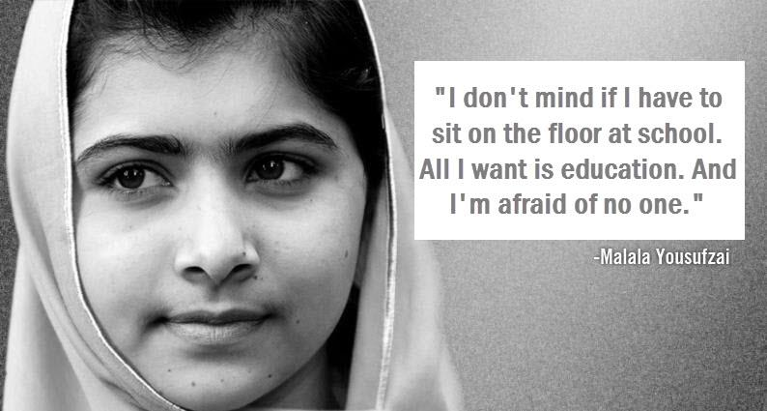
Support Human Dignity – Stand up to extremism – Make a Difference

