Walk-a-thon for Syria Information
Wednesday, October 21st, 2015, 2:30-4:00PM, Springville Middle School
Sponsored by the Springville Students for Human Rights
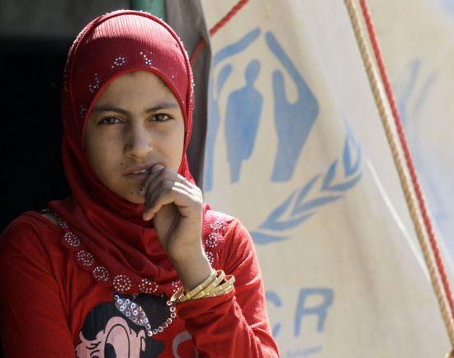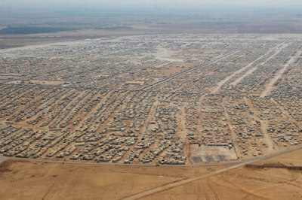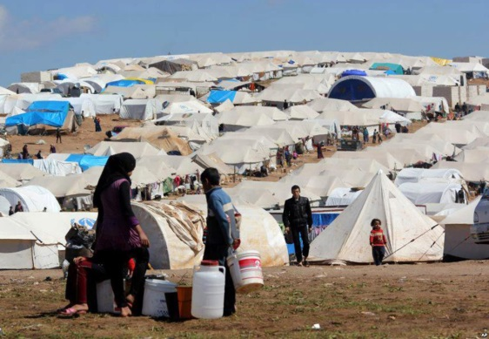

Purpose and Background:
In order to connect the study of history to the world today, the Springville Students for Human Rights is proud to sponsor “A Walkathon for Syria”—a three mile walk and educational event on Wednesday, October 21st from 2:30-4:00PM. Given that the revolution in Syria was started four years ago by 12 years olds in the town of Daraa who wrote “The government must go!” on the side of their school, it seems fitting for students here in the United States to relate to their suffering and want to help. Since then, the plight of Syrian civilians is alarming. Nine million Syrians--approaching half of the country’s pre-war population—have fled their homes, with over six and a half million people internally displaced. Of this number, three million are trapped in hard-to-reach or besieged areas; an estimated 250,000 people have been cut off from assistance for over a year, made even more dire by the advance of ISIS.

Getting Pledges and Raising Money:
Seeing that virtually all of these refugees had to flee from their homes by foot, the Walkathon here in Springville is symbolic; but also, serves as a fundraiser. Each participant will be asked to raise at least $20 in pledges that will be donated to the International Rescue Committee’s Fund for Syrian Refugees, www.rescue.org Likewise, each walker will be asked to bring a pair of gently used sneakers, shoes, or boots that will be donated to Planet Aid, a nonprofit organization that collects used shoes to impoverished communities around the world, www.planetaid.org

Walkathon Information Side Two

Agenda:
2:15-2:30 Study Hall in Mr. Beiter’s room
2:30-2:45 Greetings and why we’re here; collection of shoe donations
2:45-3:45 A three mile walk within the Middle School building
3:45-4:00 Debrief and Reflections

What you’ll need:
1. A good pair of sneakers to walk in!
2. A pair of old shoes, sneakers, or boots to donate to Planet Aid.
3. A Signed permission slip turned in to me before the event.
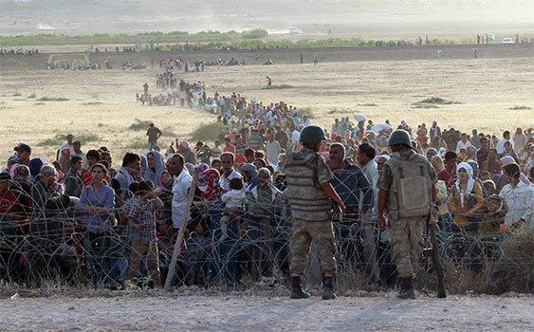
Syrian Refugees attempting to flee into Turkey, Fall 2014
Walkathon Liability Waiver and Permission Form for Parents:
I grant full permission for my daughter/son ___________________ to participate in the Walkathon for Syrian Refugees at Springville Middle School on Wednesday, October 21st. I understand that the walk will be three miles and that my child is physically capable of performing such an activity.
__________________________ _____________
Parent Signature Date

Pledge Form for Students:
I understand that the walk is five miles and that it is important that I try to get at least $20 in pledges from my friends, family, and other adults. ALL MONEY IS DUE TO MR. BEITER NO LATER THAN FRIDAY, OCTOBER 30TH.
__________________________ ______________
Student Signature: Date:

Walker Pledge Sheet: (Checks can be made payable to Springville Students for Human Rights)
Sponsor Name: Pledge Amount: Check#: Cash: Total Collected:
_______________________________________________________________________________________________________________________________________________________________________________________________________________________________________________________________________________________________________________________________________________________________________________________________________________________________________________________________________________________________________________________________________________________________________________________________________________________________________________________________________________________________________________________________________________
TOTAL: _________

ALL MONEY MUST BE TURNED IN TO MR. BEITER NO LATER THAN FRIDAY, OCTOBER 30TH. THANK YOU FOR PARTICIPATING!

