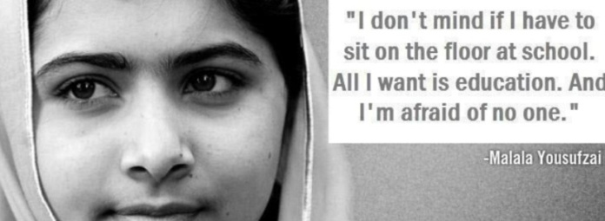
Dear Springville Parents, March 15, 2013
In order to promote international education to our students, the Human Rights Club will be organizing a school wide Penny Drive next week to aid girls’ education in Afghanistan. Inspired by the tragic shooting of the Pakistani girl Malala by the Taliban last October, the goal of the drive is not only to raise awareness about the power of education, but to help our students understand their influence as world citizens.
Approved by the Springville Board of Education, the Penny Drive will go from this Monday, March 18th through Friday the 22nd. All students are encouraged to bring in old pennies or assorted loose change of any kind to their homeroom each day. The proceeds will go to a group in Afghanistan with strong Buffalo connections called SOLA—School of Leadership Afghanistan—which is a boarding school for future female leaders in Kabul, with information at www.sola-afghanistan.org
How can a penny bring peace? It doesn’t buy much in our community. However, in the villages of Pakistan and Afghanistan, a penny can buy a pencil, start an education, and transform a life. In a region where terrorist organizations recruit uneducated, illiterate children, that pencil can empower a child to read, write, and learn. All this helps limit the growth of extremism, which in turn keeps our troops—and country—a little bit safer. If you have any questions about our Pennies for Peace campaign, please feel free to contact 8th Grade Social Studies Teacher Mr. Beiter at abeiter@springvillegi.org All denominations of coins will gladly be accepted. Thank you for your cooperation and support!
Sincerely,
Springville Students for Human Rights, Drew Beiter, Advisor
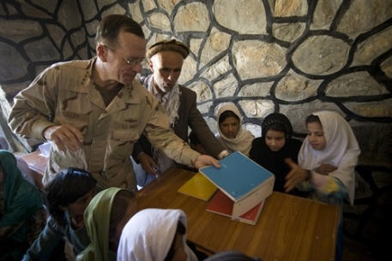
U.S. Admiral Mike Mullen giving books to a school in Afghanistan

